## Introduction

For this project, a visualization system for grouping students by skills and competences has been developed.

## Workflow

### Data Cleaning

The data was cleaned by the removal of data fields in the Microsoft Excel file. Data fields containing student generated names and numerical values was saved to the CSV file which was used in the project. Free-text responses were not saved due to some of the sentences containing commas, thus disarranging the CSV file structure. Hence, for later projects, I might consider saving data in a JSON file instead.

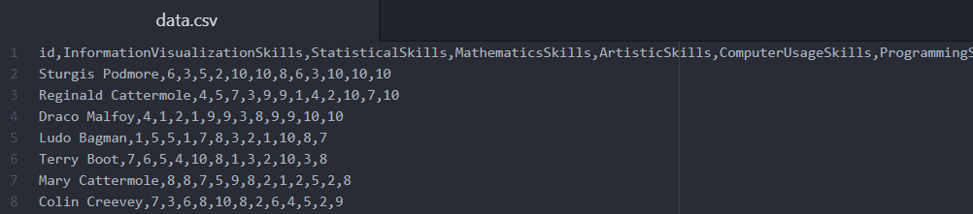

### Final Interface